VMWARE KEY HAS EXPIRED

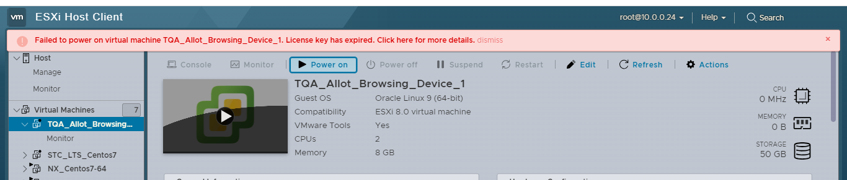

Step 1:

Login to Esxi shell using ssh

Step 2:

rm -r /etc/vmware/license.cfg

 Step 3:

cp /etc/vmware/.#license.cfg /etc/vmware/license.cfg

 Step 4:

/etc/init.d/vpxa restart